**Assignment: 1 (OOPs)**

**Name:** Yatin Kanwar **SID:** 23105057 **Branch:** ECE

**Q1. Write a C++ Program for Hello World.**

**Solution:**

#include <iostream>

using namespace std;

int main() {

    cout << "Hello, World!" << endl;

    return 0;

}

**Output:**

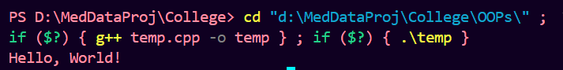

**Q2. Write a C++ Program to Print your own name.**

**Solution:**

#include <iostream>

using namespace std;

int main() {

    cout << "Yatin" << endl;

    return 0;

}

**Output:**

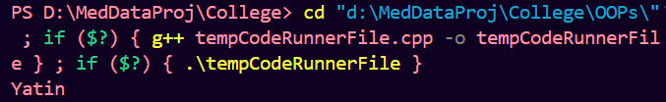

**Q3. Write a C++ Program to Get Input from the User.**

**Solution:**

#include <iostream>

using namespace std;

int main() {

    string input;

    cout << "Type Something: ";

    getline(cin, input);

    cout << "You typed: " << input << endl;

    return 0;

}

**Output:**

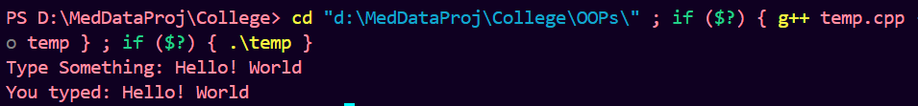

**Q4. Write a C++ Program to Read Number Input From User.**

**Solution:**

#include <iostream>

using namespace std;

int main() {

    int number;

    cout << "Enter a number: ";

    cin >> number;

    cout << "You entered: " << number << endl;

    return 0;

}

**Output:**



**Q5. Write a C++ Program to Add Two Numbers.**

**Solution:**

#include <iostream>

using namespace std;

int main() {

    int a, b;

    cout << "Enter two numbers: ";

    cin >> a >> b;

    int sum = a + b;

    cout << "Sum: " << sum << endl;

    return 0;

}

**Output:**



**Q6. Write a C++ Program to Swap two numbers.**

**Solution:**

#include <iostream>

using namespace std;

int main() {

    int a, b;

    cout << "Enter two numbers: ";

    cin >> a >> b;

    cout << "Before swapping: a = " << a << ", b = " << b << endl;

    int temp = a;

    a = b;

    b = temp;

    cout << "After swapping: a = " << a << ", b = " << b << endl;

    return 0;

}

**Output:**

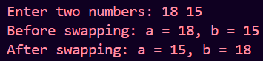

**Q7. Write a C++ Program to Find the Size of int, float, double, and char.**

**Solution:**

#include <iostream>

using namespace std;

int main() {

    cout << "Size of int: " << sizeof(int) << " bytes" << endl;

    cout << "Size of float: " << sizeof(float) << " bytes" << endl;

    cout << "Size of double: " << sizeof(double) << " bytes" << endl;

    cout << "Size of char: " << sizeof(char) << " bytes" << endl;

    return 0;

}

**Output:**

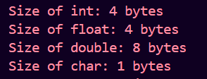

**Q8. Write a C++ Program to Multiply Two Floating-Point Numbers.**

**Solution:**

#include <iostream>

using namespace std;

int main() {

    float a, b;

    cout << "Enter two float-type numbers: ";

    cin >> a >> b;

    float result = a*b;

    cout << "Product: " << result << endl;

    return 0;

}

**Output:**



**Q9. Write a C++ Program to Print the ASCII Value of a Character.**

**Solution:**

#include <iostream>

using namespace std;

int main() {

    char ch;

    cout << "Enter a character: ";

    cin >> ch;

    cout << "ASCII value of " << ch << " is " << int(ch) << endl;

    return 0;

}

**Output:**



**Q10. Write a C++ Program to Calculate Fahrenheit to Celsius.**

**Solution:**

#include <iostream>

using namespace std;

int main() {

    float fahrenheit, celsius;

    cout << "Enter temperature in Fahrenheit: ";

    cin >> fahrenheit;

    celsius = (fahrenheit - 32) * 5.0 / 9.0;

    cout << "Temperature in Celsius: " << celsius << endl;

    return 0;

}

**Output:**



**Q11. Write a C++ Program to Find Simple Interest.**

**Solution:**

#include <iostream>

using namespace std;

int main() {

    float principal, rate, time, simpleInterest;

    cout << "Enter principal amount: ";

    cin >> principal;

    cout << "Enter rate of interest: ";

    cin >> rate;

    cout << "Enter time (in years): ";

    cin >> time;

    simpleInterest = (principal * rate * time) / 100;

    cout << "The Simple Interest will be: " << simpleInterest << endl;

    return 0;

}

**Output:**

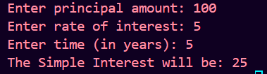

**Q12. Write a C++ Program to Find Compound Interest.**

**Solution:**

#include <iostream>

#include <cmath>

using namespace std;

int main() {

    float principal, rate, time, num_time, compoundInterest;

    cout << "Enter principal amount: ";

    cin >> principal;

    cout << "Enter annual interest rate (in %): ";

    cin >> rate;

    cout << "Enter time (in years): ";

    cin >> time;

    cout<<"Enter the number of times rate is applied in one year: ";

    cin>> num_time;

*// Convert rate from percentage to decimal*

    rate = rate / 100;

    compoundInterest = principal * pow((1 + rate),num_time*time) - principal;

    cout << "The Compound Interest will be: " << compoundInterest << endl;

    return 0;

}

**Output:**

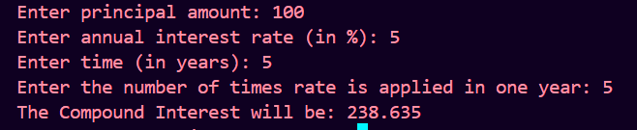

**Q13. Write a C++ Program For Area And Perimeter of Rectangle.**

**Solution:**

#include <iostream>

using namespace std;

int main() {

    float length, width, area, perimeter;

    cout << "Enter length: ";

    cin >> length;

    cout << "Enter width: ";

    cin >> width;

    area = length * width;

    perimeter = 2 * (length + width);

    cout << "Area: " << area << endl;

    cout << "Perimeter: " << perimeter << endl;

    return 0;

}

**Output:**

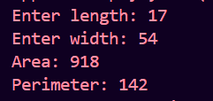

**Q14. Write a C++ Program to calculate the biggest of 3 given numbers using logical operators.**

**Solution:**

#include <iostream>

using namespace std;

int main() {

    int a, b, c;

    cout << "Enter three numbers: ";

    cin >> a >> b >> c;

    if (a >= b && a >= c) {

        cout << "The largest number is: " << a << endl;

    } else if (b >= c) {

        cout << "The largest number is: " << b << endl;

    } else {

        cout << "The largest number is: " << c << endl;

    }

    return 0;

}

**Output:**



**Q15. Write a C++ Program to find the biggest of 4 numbers using conditional operators.**

**Solution:**

#include <iostream>

using namespace std;

int main() {

    int a, b, c, d;

    cout << "Enter four numbers: ";

    cin >> a >> b >> c >> d;

    int maximum = (a >= b && a >= c && a >= d) ? a :

              (b >= c && b >= d) ? b :

              (c >= d) ? c : d;

    cout << "The largest number is: " << maximum << endl;

    return 0;

}

**Output:**



**Q16. Write a C++ Program to Bitwise AND,OR,XOR, Bitwise Shift Left and right Operator Operators.**

**Solution:**

#include <iostream>

using namespace std;

int main() {

    int a, b;

    cout << "Enter two integers: ";

    cin >> a >> b;

*// Bitwise AND*

    int andResult = a & b;

    cout << "Bitwise AND (&): " << a << " & " << b << " = " << andResult << endl;

*// Bitwise OR*

    int orResult = a | b;

    cout << "Bitwise OR (|): " << a << " | " << b << " = " << orResult << endl;

*// Bitwise XOR*

    int xorResult = a ^ b;

    cout << "Bitwise XOR (^): " << a << " ^ " << b << " = " << xorResult << endl;

*// Bitwise Shift Left*

    int shiftLeftResultA = a << 1;

    int shiftLeftResultB = b << 1;

    cout << "Bitwise Shift Left (<<): " << a << " << 1 = " << shiftLeftResultA << endl;

    cout << "Bitwise Shift Left (<<): " << b << " << 1 = " << shiftLeftResultB << endl;

*// Bitwise Shift Right*

    int shiftRightResultA = a >> 1;

    int shiftRightResultB = b >> 1; a

    cout << "Bitwise Shift Right (>>): " << a << " >> 1 = " << shiftRightResultA << endl;

    cout << "Bitwise Shift Right (>>): " << b << " >> 1 = " << shiftRightResultB << endl;

    return 0;

}

**Output:**

